Date: 1-9-2025

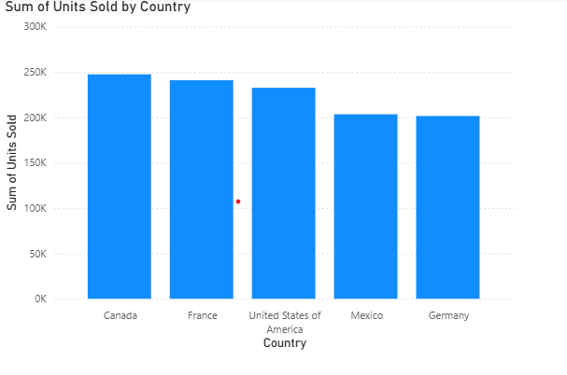

Condition- Sum of units by Country

CT- Stacked column chart

X axix- Country

**Insights:**

* Canada sold highest items
* France sold second highest units
* Germany sold least units